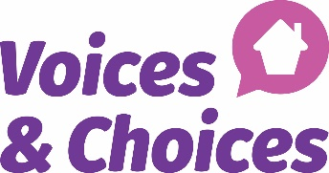

Could this affect your family member?
- Is a member of your family getting Disability Living allowance (DLA)?
- Are you aware that this benefit will stop?
- They will be asked by the Department of Work & Pensions (DWP) by letter to make a new claim for Personal Independence Payment (PIP)
- They need to make this new claim within 4 weeks of receiving the letter from DWP
- If your family member has not been getting any disability benefit they may be eligible for PIP
- We can also support you if your family member with a learning disability needs help to apply for ESA or other benefit.
If you would like to find out more about disability benefits, please make an appointment by calling Voices and Choices CIO on 01494 784566 or emailing voicesandchoices1@gmail.com. Voices and Choices is a local charity supporting people find the help they need.

